# WEEK – 1

**Aim**: To understand the Basic concepts the HTML language and heading tags

**1.What is web programming?**

Web programming refers to the writing, markup and coding involved in Web development, which includes Web content, Web client and server scripting and network security. The most common languages used for Web programming are XML, HTML, JavaScript, Perl 5 and PHP. Web programming is different from just programming, which requires interdisciplinary knowledge on the application area, client and server scripting, and database technology

**2.What is full form of HTML ? and what is its version?**

* HYPER TEXT MARKUP LANGUAGE .
* current version is HTML5

**3.How do we write code in HTML?**

<html>

<body>

<h1>My First Heading</h1>

<p>My first paragraph.</p>

</body>

</html>

**4.Difference b/w LAN,MAN & VAN?**

|  |
| --- |
| Lan:-LAN stands for local area network |
| LAN’s ownership is private. |
| The transmission speed of a LAN is high. |
| The propagation delay is short in a LAN. |
| LAN’s design and maintenance is easy. |
|  |
| Man: |
| MAN stands for metropolitan area network |
| MAN’s ownership can be private or public. |
| While the transmission speed of a MAN is average. |
| There is a moderate propagation delay in a MAN. |
| While MAN’s design and maintenance is difficult than LAN. |
|  |
|  |
| Wan:- |
|  |
| WAN stands for wide area network. |
| While WAN also might not be owned by one organization. |
| Whereas the transmission speed of a WAN is low. |

**5. Difference between physical address and logical address**

|  |
| --- |
| LOGICAL ADDRESS:- |
| basic- generated by CPU |
| Logical Address Space is set of all logical addresses generated by CPU in reference to a program. |
| User can view the logical address of a program |
| The user can use the logical address to access the physical address. |
|  |
|  |
| PHYSICAL ADDRESS:- |
| location in a memory unit |
| Physical Address is set of all physical addresses mapped to the corresponding logical addresses. |
| User can never view physical address of program. |
| Computed by MMU(Memory Management Unit) |
| The user can indirectly access physical address but not directly. |

**6.What are h1-h6 tags in HTML?**

<!DOCTYPE html>

<html>

<body>

<h1>Heading 1</h1>

<h2>Heading 2</h2>

<h3>Heading 3</h3>

<h4>Heading 4</h4>

<h5>Heading 5</h5>

<h6>Heading 6</h6>

</body>

</html>

**7. How many types of tags are there in HTML and what are they ?**

**1. Paired and Unpaired Tags**

**Paired Tags** : <p> This text is a paragraph . </p>

**Unpaired Tags :**

<p> This is a paragraph </p>

<hr>

<i> <b> This is a bold and italicized text </b> </i>

**2. Self-Closing Tags**

<img src="a.jpg" alt="This is an alternate text">

**3. Utility-Based Tags:**

* + This is done using tags like <font>, <b>, <u>, etc. Tables, divisions, and span tags are also those tags that help format a web page or document and set the layout of the page.

**8. what is a web page and what are the different types of web pages?**

* web page is a document available on world wide web. Web Pages are stored on web server and can be viewed using a web browser. A web page can cotain huge information including text, graphics, audio, video and hyper links. These hyper links are the link to other web pages

|  |
| --- |
| Types:- |
| Static web pages are also known as flat or stationary web page. They are loaded on the client’s browser as exactly they are stored on the web server. Such web pages contain only static information. User can only read the information but can’t do any modification or interact with the information. |
|  |
| Static web pages are created using only HTML. Static web pages are only used when the information is no more required to be modified. |
|  |
| **dynamic:-** |
| Dynamic web page shows different information at different point of time. It is possible to change a portaion of a web page without loading the entire web page. It has been made possible using Ajax technology. |
|  |
| Server-side dynamic web page |
| It is created by using server-side scripting. There are server-side scripting parameters that determine how to assemble a new web page which also include setting up of more client-side processing. |

**9.What is a website ?**

A website is a collection of web pages and related content that is identified by a common domain name and published on at least one web server. Notable examples are wikipedia.org, google.com, and amazon.com. All publicly accessible websites collectively constitute the World Wide Web

**Program:**

<html>

<h1> AJAY-1 </h1>

<h2> AJAY-2</h2>

<h3> AJAY-3 </h3>

<h4> AJAY-4</h4>

<h5> AJAY-5</h5>

<h6> AJAY-6</h6>

</html>

**OUTPUT:**

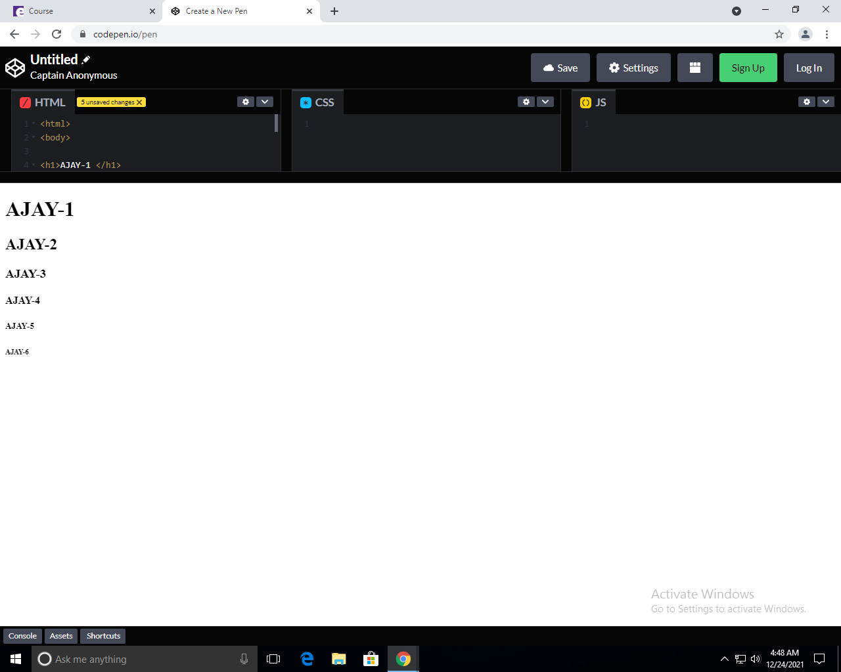

# WEEK – 2

**Aim**: To design the homepage with image tags and paragraph,bold,italic tags.

1. **What is the difference between b/n heading , title , body?**

Heading fonts and body fonts are part of the templates available to you as part of your brand.

Heading fonts are used as larger, higher impact text, such as in a title or section header

Body fonts are usually used with longer text, like a paragraph or secondary text.  We recommend an easy-to-read font that pairs well with your heading font. You may want to choose an easy to read font that compliments your heading font choice. Body fonts also support bold and italics styles.  If you’d like you can select your regular font, and we will build the italics and bold styles automatically for you, but your text will look its best when you also upload the font files all the text styling options.

1. **What is the difference between web app****lication and mobile application**

|  |
| --- |
| A difference between these two types of apps is that web apps require an active Internet connection in order to function, whereas mobile apps can often function while offline |
| Mobile apps tend to be faster and more efficient than web apps, but in order to maintain optimum functionality, users must regularly download updates, whereas web apps update themselves |
| Function in-browser, and therefore do not need to be downloaded or installed whereas mobile application need to install |
| webapps easier and faster to build than mobile apps |
| speed:-mobile application faster and web are slow |
| application is more than web application. |

1. **List out various types of tags?.**

## Various types of Tags:

* **Title tag:**

The <title> tag defines the title of the document. The title must be text-only, and it is shown in the browser's title bar or in the page's tab.

The <title> tag is required in HTML documents!

The contents of a page title is very important for search engine optimization (SEO)! The page title is used by search engine algorithms to decide the order when listing pages in search results.

The <title> element:

* defines a title in the browser toolbar
* provides a title for the page when it is added to favorites
* displays a title for the page in search-engine resume
* **Strong Tag:**

The <strong> tag is used to define text with strong importance. The content inside is typically displayed in **bold**.

* **Center Tag:**

<center> ……………….. </center> : places at the center of web-page

* **Small tags:**
* 1. <b> ………………. </b> : bolds the string
* 2. <U> ………………………….. </U> : underlines the string
* 3. <i> …………………………. </i> : string will be in italic style

**Image tag:**

<img src “pic url” align=”right” or align=”left” or align=”center” width=”100” height=”100” >

Src : image source

Width & height : they are image dimensions

**Hyper – link tag:**

<a href=”link url”> link-name </a>

**Program:**

|  |
| --- |
|  |
|  | <html> |
|  |  |
|  | <body bgcolor="azure"> |
|  |  |
|  | </head> |
|  | <body> |
|  |  |
|  | <center><h1 align="center" style="color:red;"><b><i><u>Resume</u></i></b></h1></center> |
|  |  |
|  | <img src="https://ajaykumarvarma.github.io/Labs/web%20programming/week4-web-resume-3frames/mypic.jpg" alt="AJAY" align=right width="200" height="200"> |
|  | <h2>N.Ajay Kumar Varma</h3> |
|  | <h4>9392593332</h4> |
|  | <h4>ajaynagaraju32@gmail.com</h4> |
|  | <h4 >ajaykumar32</h4> |
|  |  |
|  | <b><i><p>I'm Ajay Kumar Varma studying btech Second year in vrsec in branch of Information Technology.I have completed my intermediate in Narayana college vijayawada and my tenth class in Narayana school.My goal is to become a software engineer and cyber security.My dream company is amazon,and any good cyber security related company.Iam well interested in bug bounty,programming,ethical hacking.My dream package is above 12 lakh.My hobbies are reading books,completing courses and get certificates,learning new things etc.. and Coming to my parents details my father name is ncs raju and mother name is Sireesha.My father occupation is pvt employee and my mother is house wife.My role model is my sister.</p></i></b> |
|  | </body> |
|  | </html> |
|  |  |

**OUTPUT:**

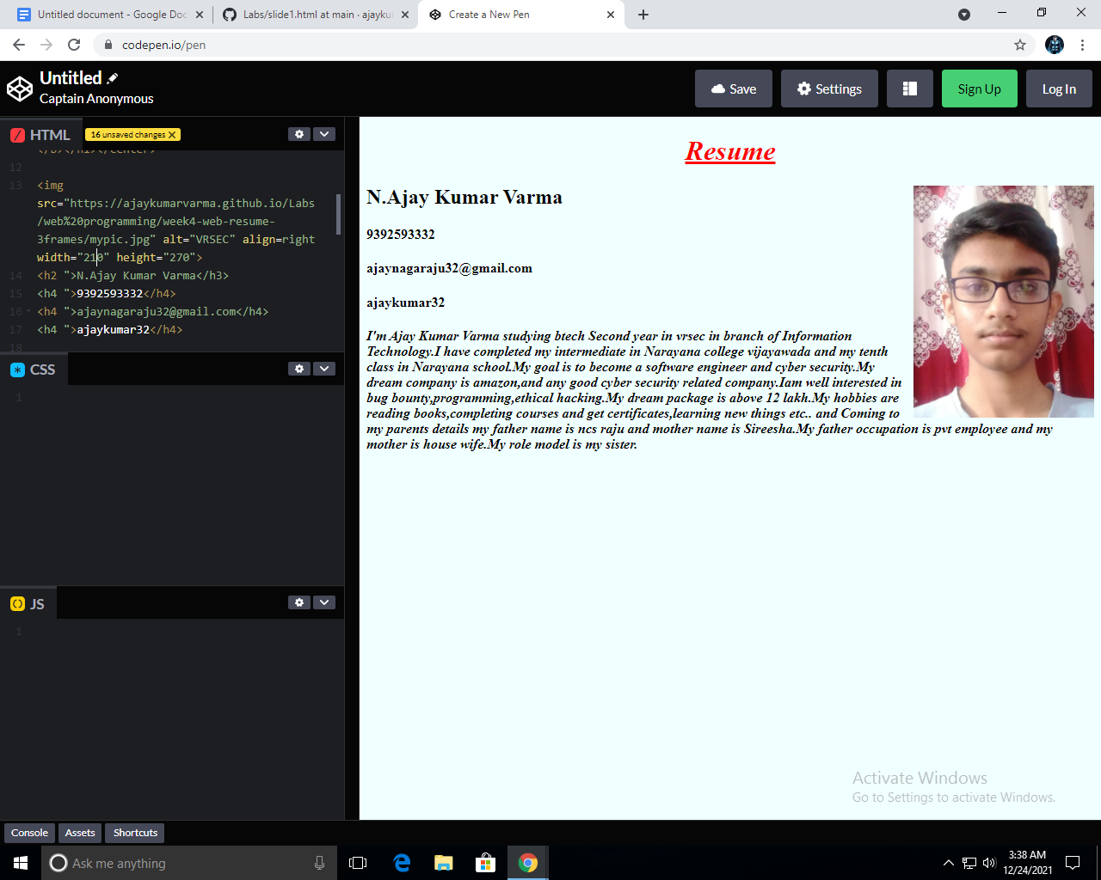

# WEEK-3

**Aim**: Create an Ordered and unordered Lists and Insert an Video,audio Into an webpage

## 

## Lists:

**What are lists in HTML language and types of Lists?**

There are 2 types of lists and they are:

* Ordered Lists
* Unordered Lists

**Ordered Lists:**

* An ordered list starts with the <ol> tag. Each list item starts with the <li> tag.The list items will be marked with numbers by default.
* The HTML <ol> tag defines an ordered list. An ordered list can be numerical or alphabetical.

**Type attributes in Ordered list:**

The type attribute of the <ol> tag, defines the type of the list item marker:

|  |  |
| --- | --- |
| **Type** | **Description** |
| type="1" | The list items will be numbered with numbers (default) |
| type="A" | The list items will be numbered with uppercase letters |
| type="a" | The list items will be numbered with lowercase letters |
| type="I" | The list items will be numbered with uppercase roman numbers |
| type="i" | The list items will be numbered with lowercase roman numbers |

**Syntax: (ordered list)**

<ol type=” ”>

<li>………………………………….</li>

<li> …………………………………..</li>

<li>………………………………….</li>

<ol>

* Use the HTML <ol> element to define an ordered list
* Use the HTML type attribute to define the numbering type
* Use the HTML <li> element to define a list item
* Lists can be nested
* List items can contain other HTML elements

## Unordered List:

## 1)An unordered list starts with the <ul> tag. Each list item starts with the <li> tag.

## 2)The list items will be marked with bullets (small black circles) by default

## 3)The HTML <ul> tag defines an unordered (bulleted) list.

**Type attributes in unordered lists:**

* The type attribute of the <ul> tag, defines the type of the list item marker:

|  |  |
| --- | --- |
| **Value** | **Description** |
| disc | Sets the list item marker to a bullet (default) |
| circle | Sets the list item marker to a circle |
| square | Sets the list item marker to a square |
| none | The list items will not be marked |

**Unordered lists syntax:**

<ul type=””>

<li>……………………………….</li>

<li>………………………………..</li>

<li>…………………………………</li>

<ul>

**Video Tag:**

The <video> tag is used to embed video content in a document, such as a movie clip or other video streams.

The <video> tag contains one or more [<source>](https://www.w3schools.com/tags/tag_source.asp) tags with different video sources. The browser will choose the first source it supports.

The text between the <video> and </video> tags will only be displayed in browsers that do not support the <video> element.

There are three supported video formats in HTML: MP4, WebM, and OGG.

**Attributes in video tag:**

|  |  |  |
| --- | --- | --- |
| **Attribute** | **Value** | **Description** |
| [autoplay](https://www.w3schools.com/tags/att_video_autoplay.asp) | autoplay | Specifies that the video will start playing as soon as it is ready |
| [controls](https://www.w3schools.com/tags/att_video_controls.asp) | controls | Specifies that video controls should be displayed (such as a play/pause button etc). |
| [height](https://www.w3schools.com/tags/att_video_height.asp) | *pixels* | Sets the height of the video player |
| [loop](https://www.w3schools.com/tags/att_video_loop.asp) | loop | Specifies that the video will start over again, every time it is finished |
| [muted](https://www.w3schools.com/tags/att_video_muted.asp) | muted | Specifies that the audio output of the video should be muted |
| [poster](https://www.w3schools.com/tags/att_video_poster.asp) | *URL* | Specifies an image to be shown while the video is downloading, or until the user hits the play button |
| [preload](https://www.w3schools.com/tags/att_video_preload.asp) | auto metadata none | Specifies if and how the author thinks the video should be loaded when the page loads |
| [src](https://www.w3schools.com/tags/att_video_src.asp) | *URL* | Specifies the URL of the video file |
| [width](https://www.w3schools.com/tags/att_video_width.asp) | *pixels* | Sets the width of the video player |

**Syntax for Video tag:**

<video width = “ “ height = “ ” poster = “.png/.jpeg/url“ controls>

<source src = “url or path of file.mp4” type = “video/mp4”>

(or)

<source src = “url or path of file.ogg” type = “video/ogg”>

</video>

**Audio Tag:**

The <audio> tag is used to embed sound content in a document, such as music or other audio streams.

The <audio> tag contains one or more [<source>](https://www.w3schools.com/tags/tag_source.asp) tags with different audio sources. The browser will choose the first source it supports.

The text between the <audio> and </audio> tags will only be displayed in browsers that do not support the <audio> element.

There are three supported audio formats in HTML: MP3, WAV, and OGG.

**Attributes in Audio tag:**

|  |  |  |
| --- | --- | --- |
| **Attribute** | **Value** | **Description** |
| [autoplay](https://www.w3schools.com/tags/att_audio_autoplay.asp) | autoplay | Specifies that the audio will start playing as soon as it is ready |
| [controls](https://www.w3schools.com/tags/att_audio_controls.asp) | controls | Specifies that audio controls should be displayed (such as a play/pause button etc) |
| [loop](https://www.w3schools.com/tags/att_audio_loop.asp) | loop | Specifies that the audio will start over again, every time it is finished |
| [muted](https://www.w3schools.com/tags/att_audio_muted.asp) | muted | Specifies that the audio output should be muted |
| [preload](https://www.w3schools.com/tags/att_audio_preload.asp) | auto metadata none | Specifies if and how the author thinks the audio should be loaded when the page loads |
| [src](https://www.w3schools.com/tags/att_audio_src.asp) | *URL* | Specifies the URL of the audio file |

**Syntax for Audio Tag:**

<audio controls>

<source src = “url or path of file.mp3” type = “audio/mpeg”>

(or)

<source src = “url or path of file.ogg” type = “audio/ogg”>

</audio>

**Program-1:**

|  |
| --- |
|  |

<html>

<body bgcolor="azure">

</head>

<body>

<center><h1 align="center" style="color:red;"><b><i><u>Resume</u></i></b></h1></center>

<img src="https://ajaykumarvarma.github.io/Labs/web%20programming/week4-web-resume-3frames/mypic.jpg" alt="VRSEC" align=right width="200" height="200"">

<h2>N.Ajay Kumar Varma</h3>

<h4>Contact Number: 9392593332</h4>

<h4>Email: ajaynagaraju32@gmail.com</h4>

<p> <a href="https://github.com/ajaykumarvarma">Github Profile</a></p>

<p>I'm Ajay Kumar Varma. My age is 18. I'm studying btech Second year in vrsec in branch of Information Technology.I have completed my intermediate in Narayana college vijayawada and my tenth class in Narayana school.My goal is to become a software engineer and cyber security.My dream company is amazon,and any good cyber security related company.Iam well interested in bug bounty,programming,ethical hacking.My dream package is above 12 lakh.My hobbies are reading books,completing courses and get certificates,learning new things etc.. and Coming to my parents details my father name is ncs raju and mother name is Sireesha.My father occupation is pvt employee and my mother is house wife.My role model is my sister.</p>

<h2>My Skill Set</h2>

<h3>Languages Known:</h3>

<ol type="1">

<li>English</li>

<li>Telugu</li>

<li>Hindi</li>

</ol>

<h3>Programming Languages Known:</h3>

<ol type="1">

<li>Python</li>

<li>c</li>

<li>c++</li>

<p> <b> Self-Affirmation Video </b> </p>

<video width = "350" height = "250" controls>

<source src = "https://ajaykumarvarma.github.io/Labs/web%20programming/VIDEO%20RESUME.mp4">

</video>

<p> <b>Self-Affirmation Audio </b> </p>

<audio controls>

<source src = "https://ajaykumarvarma.github.io/Labs/web%20programming/AUDIORESUME.mp3">

</audio>

<p> <b> Hobbies: </b> </p>

<ul type="disc">

<li> Listening Music </li>

<li> Browsing in internet </li>

<li> Improving coding skills </li>

</ul>

<br>

<h2>Other Details:</h2>

<p> DOB: 30-05-2003 </p>

<p> Age: 18 </p>

<p> Fathers name: Ncs Raju </p>

<p> Address: 74-10-1/9,Road No:9,Electricity Colony,Patamata,Vijayawada </p>

</ul>

</body>

</html>

**Program-2:**

|  |
| --- |
|  |

|  |
| --- |
| <html> |
|  | <body> |
|  | <title>Lists</title> |
|  | <h1 align="center"><b><u>Different types of lists</u></b></h1> |
|  | <h2><u>Ordered list:</u></h2> |
|  | <h3>Friends:</h3> |
|  | <ol type="1"> |
|  | <li>Rizwan</li> |
|  | <li>Sai</li> |
|  | <li>charan</li> |
|  | <li>Mounav</li> |
|  |  |
|  | </ol> |
|  | <h3>Cars:</h3> |
|  | <ol type="a"> |
|  | <li>Audi</li> |
|  | <li>Benz</li> |
|  | <li>Rolls Roice</li> |
|  | <li>Ferrari</li> |
|  |  |
|  | </ol> |
|  | <h3>Bikes:</h3> |
|  | <ol type="A"> |
|  | <li>Ducati</li> |
|  | <li>Pulsar</li> |
|  | <li>R15</li> |
|  | <li>Gixer</li> |
|  |  |
|  | </ol> |
|  | <h3>Flowers:</h3> |
|  | <ol type="I"> |
|  | <li>Rose</li> |
|  | <li>Lilly</li> |
|  | <li>SunFlower</li> |
|  | <li>Tulips</li> |
|  |  |
|  | </ol> |
|  |  |
|  | <h2><u>Un ordered list:</u></h2> |
|  | <h3>Programing Languages:</h3> |
|  | <ul> |
|  | <li>Python</li> |
|  | <li>cpp</li> |
|  | <li>c</li> |
|  | <li>java</li> |
|  | </ul> |
|  | <h3>Social Media:</h3> |
|  | <ul style="list-style-type:square;"> |
|  | <li>Facebook</li> |
|  | <li>Whatsapp</li> |
|  | <li>Instagram</li> |
|  | <li>Twitter</li> |
|  | </ul> |
|  | <h3>Cool Drinks:</h3> |
|  | <ul style="list-style-type:circle;"> |
|  | <li>Thumbsup</li> |
|  | <li>Sprite</li> |
|  | <li>Maaza</li> |
|  | <li>7up</li> |
|  | </ul> |
|  | <h3>Mnc's:</h3> |
|  | <ul style="list-style-type:none;"> |
|  | <li>Amazon</li> |
|  | <li>Microsoft</li> |
|  | <li>Google</li> |
|  | <li>Airbus</li> |
|  | </ul> |
|  |  |
|  |  |
|  | </body> |
|  | </html> |

**OUTPUT:**

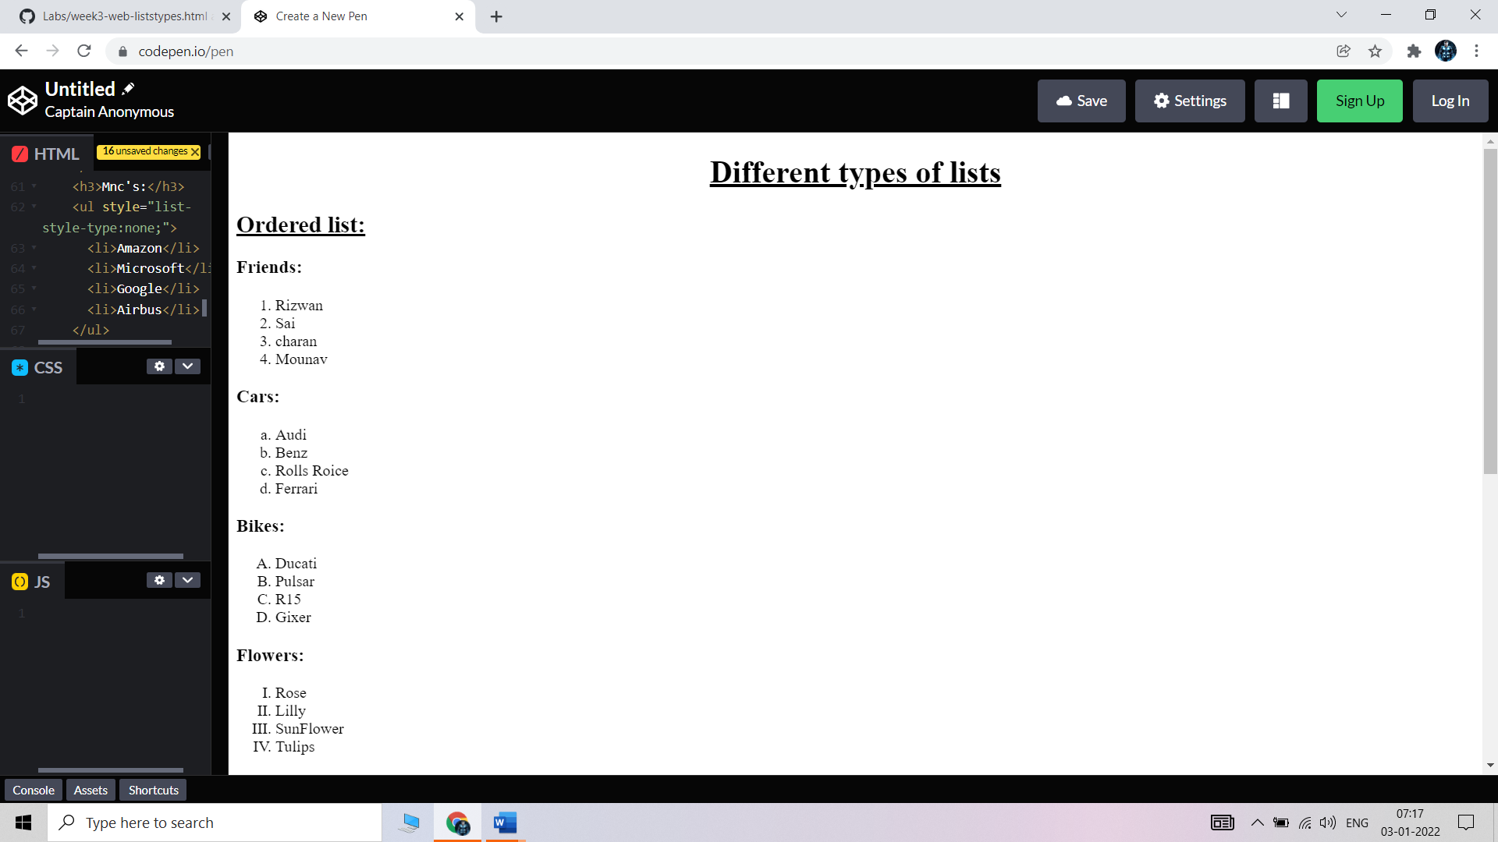

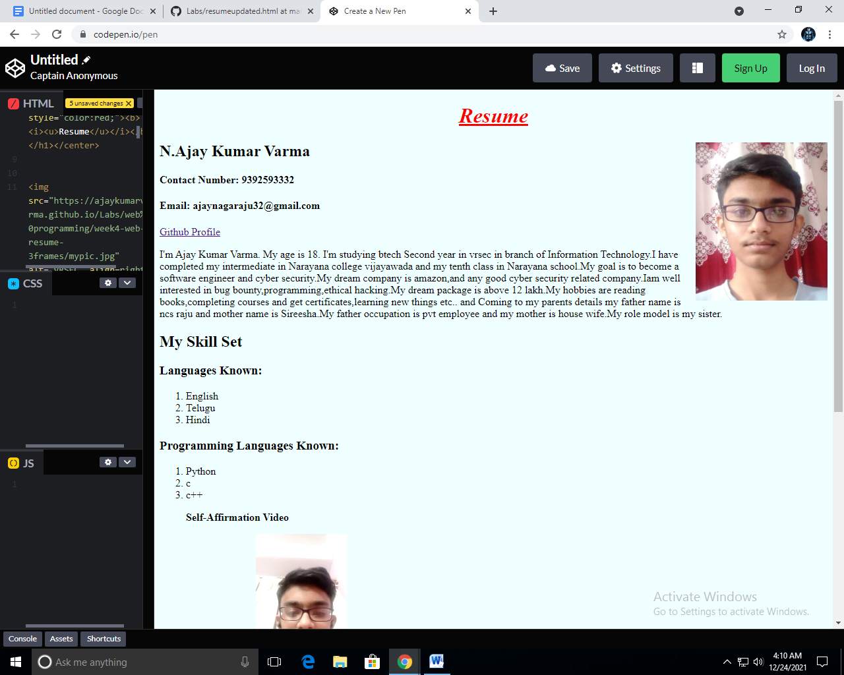

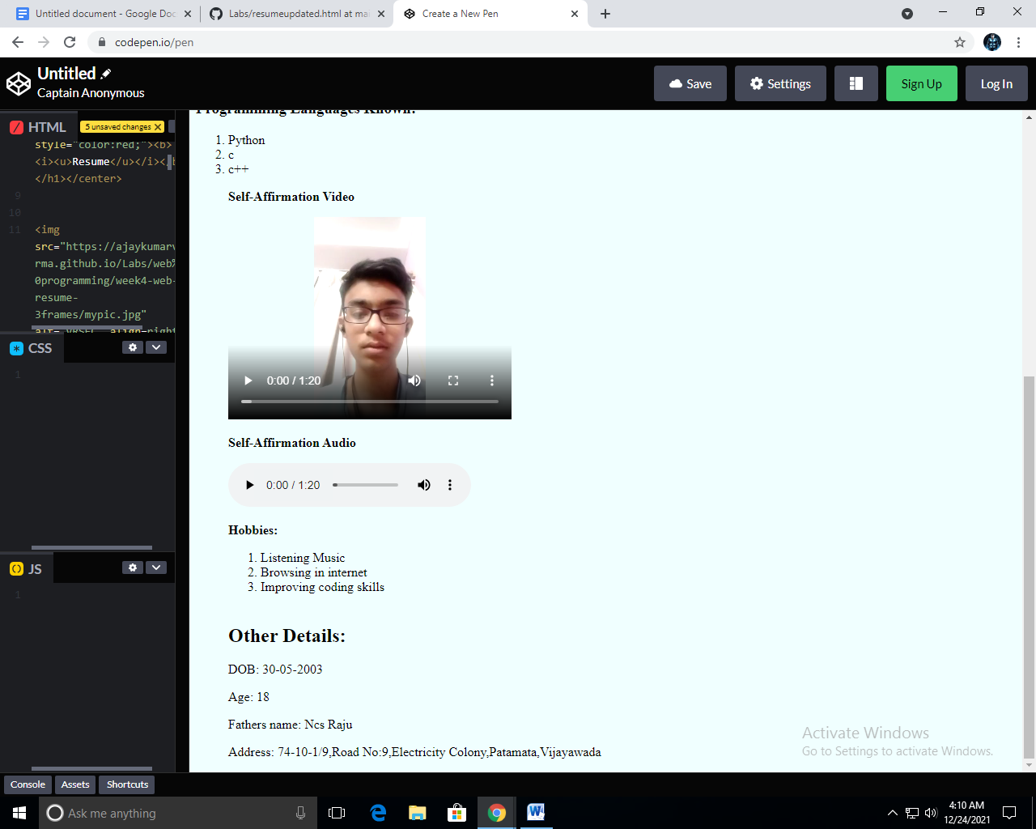

**OUTPUT UNORDERED LIST:-**

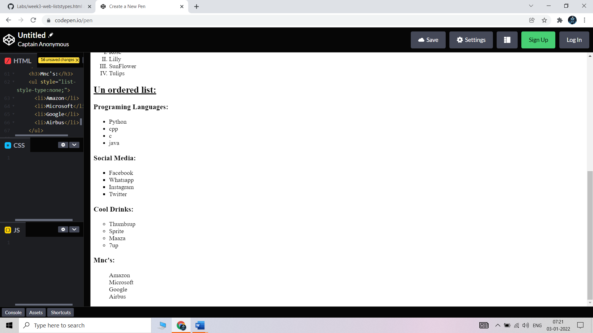

# Week – 4

**Aim**: Create an your Resume by using framset tag and using HTML language.

## **Frameset:**

The <frameset> tag in HTML is used to define the frameset. The

<frameset> element contains one or more frame elements. It is used to specify the number of rows and columns in frameset with their pixel of spaces. Each element can hold a separate document.

HTML frames are used to divide your browser window into multiple sections where each section can load a separate HTML document. A collection of frames in the browser window is known as a frameset. The window is divided into frames in a similar way the tables are organized: into rows and columns.

## 

## **Attributes in Frameset:**

**cols**: The cols attribute is used to create vertical frames in a web browser. This attribute is basically used to define the no. of columns and their size inside the frameset tag.

**rows:** The rows attribute is used to create horizontal frames in the web browser. This attribute is used to define the no. of rows and their size inside the frameset tag.

**border:** This attribute of frameset tag defines the width of the border of each frame in pixels. Zero value is used for no border.

**frameborder:** This attribute of frameset tag is used to specify whether a three-dimensional border should be displayed between the frames or not for this use two values 0 and 1, where 0 defines no border and value 1 signifies for yes there will be a border.

**framespacing:** This attribute of frameset tag is used to specify the amount of spacing between the frames in a frameset. This can take any integer value as a parameter which basically denotes the value in pixel.

**Syantax For Column’s Division:**

<frameset cols = “n1%, n2%, n3%>

<frame name = “top” src = “first file.html” />

<frame name = “main” src = “second file.html” />

<frame name = “bottom” src = “third file.html” />

.

.

.

.

<noframes>

<body>

You can write here documentation.

n1,n2,n3 are the division of web-page percentages.

</body>

</noframes>

</frameset>

**Syantax For Row’s Division:**

<frameset rows = “n1%, n2%, n3%>

<frame name = “top” src = “first file.html” />

<frame name = “main” src = “second file.html” />

<frame name = “bottom” src = “third file.html” />

.

.

.

.

<noframes>

<body>

You can write here documentation.

n1,n2,n3 are the division of web-page percentages.

</body>

</noframes>

</frameset>

**Program:**

|  |  |
| --- | --- |
|  | |
| <html> | |
|  | | <head> |
|  | | <title>Resume</title> |
|  | | </head> |
|  | |  |
|  | | <frameset cols = "25%, 38%, 37%"> |
|  | | <frame name = "top" src = "[slide1.html](https://webprogramming.ajaykumarvarma.live/web%20programming/week4-web-resume-3frames/slide1.html)" /> |
|  | | <frame name = "main" src = "[slide2.html](https://webprogramming.ajaykumarvarma.live/web%20programming/week4-web-resume-3frames/slide2.html)" /> |
|  | | <frame name = "bottom" src = "[slide3.html](https://webprogramming.ajaykumarvarma.live/web%20programming/week4-web-resume-3frames/slide3.html)" /> |
|  | | <noframes> |
|  | | <body>The browser you are working does |
|  | | not support frames.</body> |
|  | | </noframes> |
|  | | </frameset> |
|  | | </html> |

**OUTPUT:**

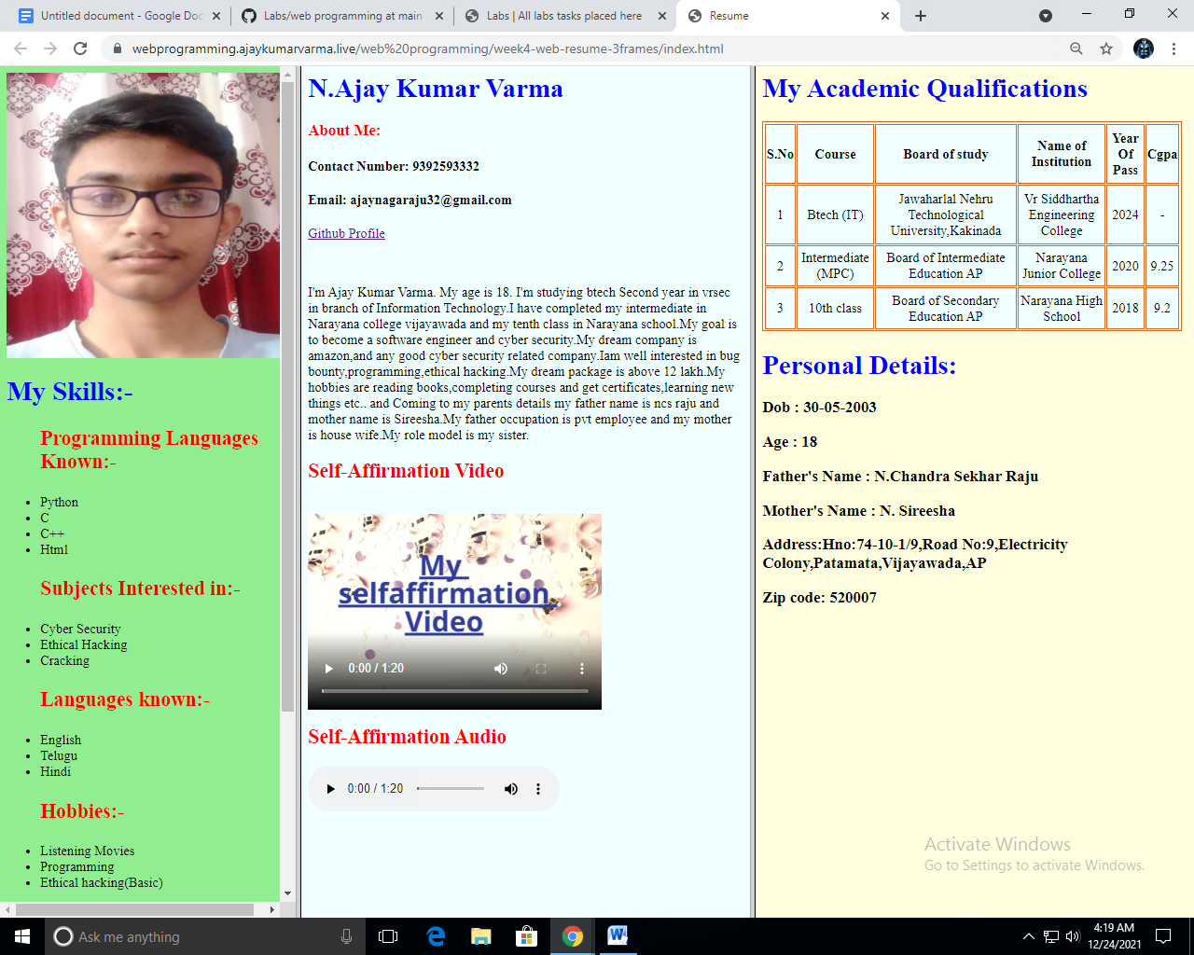

# WEEK – 5

**Aim**: To create an Academic Qualifications Table using Table tag in HTML

## 

## **Tables:**

* HTML tables allow web developers to arrange data into rows and columns.
* The HTML tables are created using the **<table>** tag in which the **<tr>** tag is used to create table rows and **<td>** tag is used to create data cells. The elements under <td> are regular and left aligned by default

**Table Heading:**

* Table heading can be defined using **<th>** tag. This tag will be put to replace <td> tag, which is used to represent actual data cell. Normally you will put your top row as table heading as shown below, otherwise you can use <th> element in any row. Headings, which are defined in <th> tag are centered and bold by default.

**Cellpadding and Cellspacing:**

* There are two attributes called cellpadding and cellspacing which you will use to adjust the white space in your table cells. The cellspacing attribute defines space between table cells, while cellpadding represents the distance between cell borders and the content within a cell.

**Table Height and Width:**

* You can set a table width and height using width and height attributes. You can specify table width or height in terms of pixels or in terms of percentage of available screen area.

**Table Backgrounds:**

1)You can set table background using one of the following two ways −

2)bgcolor attribute − You can set background color for whole table or just for one cell.

3)background attribute − You can set background image for whole table or just for one cell.

4)You can also set border color also using bordercolor attribute

Table Header: use <th> ……………………………… </th>

Table rows or colums: use <tr> ………………………… </tr>

Table Data: use <tc> …………………………………….. </tc>

## Attributes in Table Tag:

|  |  |
| --- | --- |
| **Tag** | **Description** |
| [<table>](https://www.w3schools.com/tags/tag_table.asp) | Defines a table |
| [<th>](https://www.w3schools.com/tags/tag_th.asp) | Defines a header cell in a table |
| [<tr>](https://www.w3schools.com/tags/tag_tr.asp) | Defines a row in a table |
| [<td>](https://www.w3schools.com/tags/tag_td.asp) | Defines a cell in a table |
| [<caption>](https://www.w3schools.com/tags/tag_caption.asp) | Defines a table caption |
| [<colgroup>](https://www.w3schools.com/tags/tag_colgroup.asp) | Specifies a group of one or more columns in a table for formatting |
| [<col>](https://www.w3schools.com/tags/tag_col.asp) | Specifies column properties for each column within a <colgroup> element |
| [<thead>](https://www.w3schools.com/tags/tag_thead.asp) | Groups the header content in a table |
| [<tbody>](https://www.w3schools.com/tags/tag_tbody.asp) | Groups the body content in a table |
| [<tfoot>](https://www.w3schools.com/tags/tag_tfoot.asp) | Groups the footer content in a table |

**Syntax For Table:**

<table border = “ ” width = “ ” height = “ ” cellspacing = “ ” bordercolor = “ ” bgcolor = “ ” >

<tr>

<th> ……………………………………….. </th>

.

.

.

</tr>

<tr>

<td> ………………………………………… </td>

<td> ……………………………………….. </td>

.

.

.

.

</tr>

.

.

</table>

**Program:**

|  |
| --- |
|  |

<html>

<body>

<table border="2" width="670" height="275" bordercolor="chocolate" bgcolor="azure" >

<tr>

<th>S.No</th>

<th>Course</th>

<th>Board of study</th>

<th>Name of Institution</th>

<th>Year Of Pass</th>

<th>Cgpa</th>

</tr>

<tr>

<td align="center">1</td>

<td align="center">Btech (IT)</td>

<td align="center">Jawaharlal Nehru Technological University,Kakinada</td>

<td align="center">Vr Siddhartha Engineering College</td>

<td align="center">2024</td>

<td align="center">-</td>

</tr>

<tr>

<td align="center">2</td>

<td align="center">Intermediate (MPC)</td>

<td align="center">Board of Intermediate Education AP</td>

<td align="center">Narayana Junior College</td>

<td align="center">2020</td>

<td align="center">9.25</td>

</tr>

<tr>

<td align="center">3</td>

<td align="center">10th class</td>

<td align="center">Board of Secondary Education AP</td>

<td align="center">Narayana High School</td>

<td align="center">2018</td>

<td align="center">9.2</td>

</tr>

</table>

</body>

</html>

**OUTPUT:**

